1. **Home Page**

This page displays a brief report with the books which have to be returned today.

1. **1. Books with return due today**

The fields displayed in the report are:

1. **Days** – number of days passed since each book was scheduled to be returned
2. **ScheduledReturnDate** – The date on which the book was scheduled to be returned
3. **LeaseDate** – the date of book’s lease
4. **UserName** – The user who made the book lease request
5. **FullName** – The full name of the user who made the book lease request
6. **Email** – user’s email
7. **CNP** – the CNP of of the the user who made the book lease request
8. **BookName** – the leased book’s name
9. **ISBN** – the leased book’s ISBN
10. **HasDisk** – if the book has an attached disk (cd, dvd)
11. **Copies** – how many book copies has the user leased
12. **Remarks** – any other notes made when the user leased the book

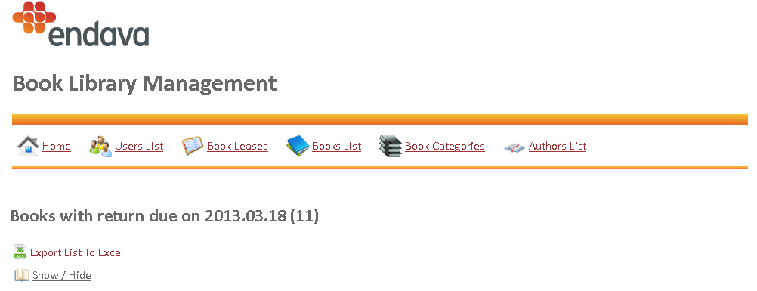

This table can be toggled on / off by pressing on the **Show / Hide** link: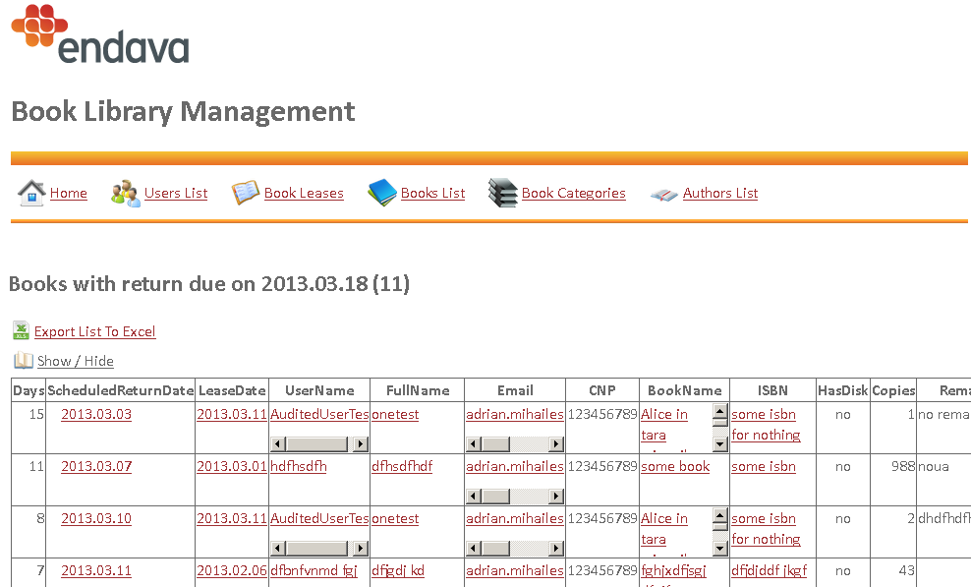

**I.2. Export list to Excel**

The user can export this list to Excel by pressing the button.

1. **Users Page**

This page displays a list with all users registered in the application’s database

**II.1. Users list**

The operator cand use filters to search for a specific user:

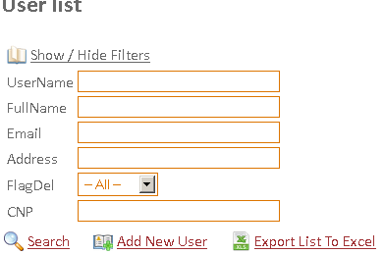

The fields displayed in the report are:

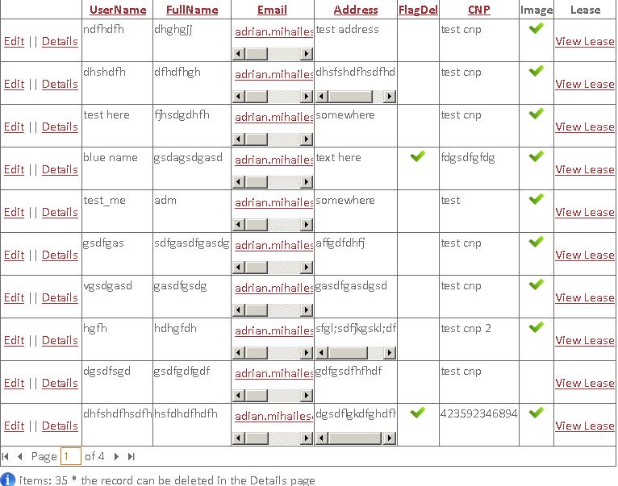

1. **UserName**
2. **FullName** – the user’s full name as registered in the application’s database
3. **Email** – the user’s e-mail
4. **Address** – the user’s address
5. **FlagDel** – This field indicates that the user is no longer active in the system. You can switch to see only the active users by changing the page filters
6. **CNP** – the user’s CNP
7. **Image** – shows weather the user has a picture registered in the system
8. **Lease** – shows all the user’s book leases

This table can be toggled on / off by pressing on the **Show / Hide Filters** link

**II.2. Add New User**

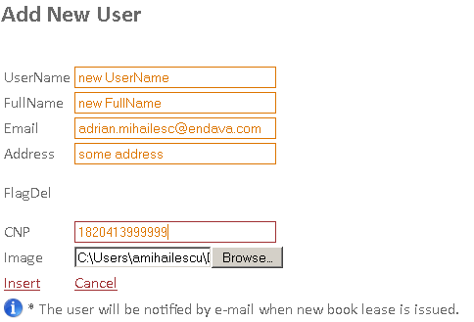

**CNP**: the unique identifier of the user

**Image**: the user’s picture (if available).

The **Image** field is optional (jpg | jped | bmp | png | gif | tif | tiff).

Please enter a valid e-mail address, because this e-mail address will be used to send an e-mail to this user when a new book lease is issued for him / her

Click **Insert**

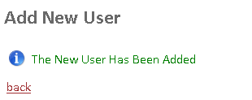

The new user will be added with the no FlagDel.



**II.3. Show User Details**

Click Details on the user’s corresponding row

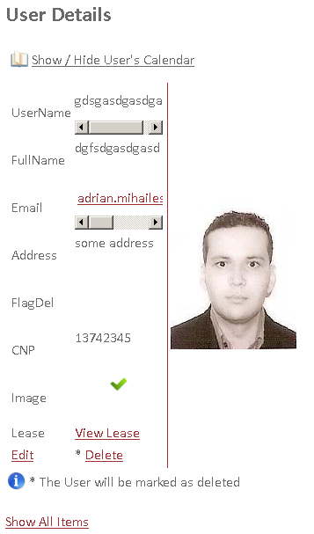

**II.4. User’s Calendar**

Shows the user’s scheduled dates of book return.

In paranthesis, you can see the number of books scheduled to be returned by the specified user every day of the calendar.

This information can be toggled on / off by pressing the **Show / Hide User’s Calendar**

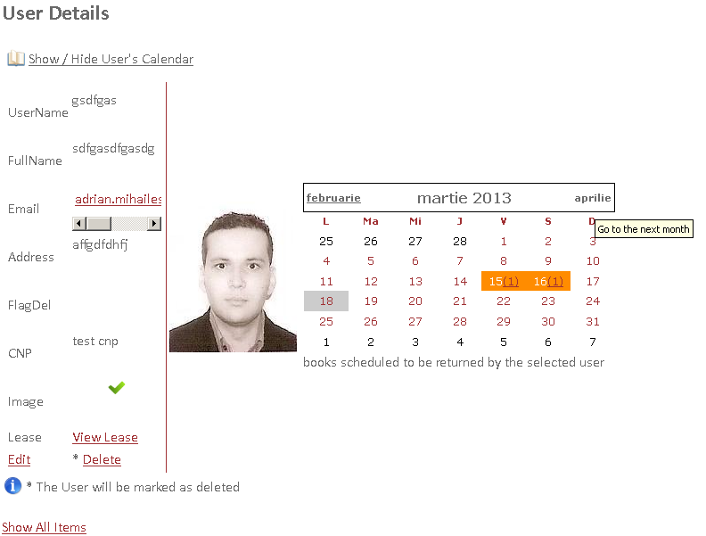

**II.5. Delete User**

**Confirm** you want to delete this user

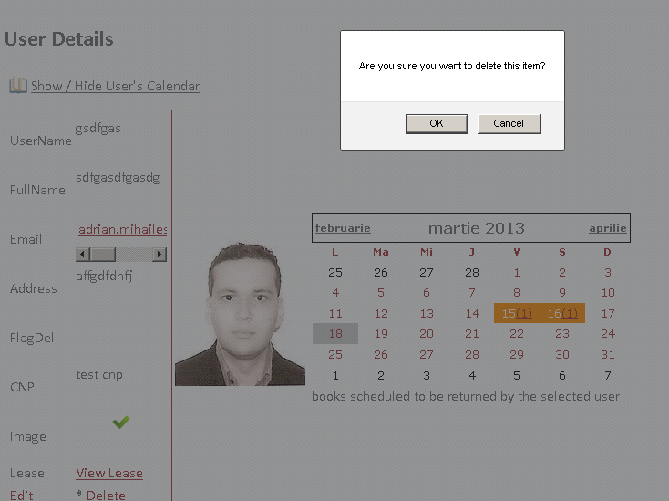

The user will be marked as deleted.

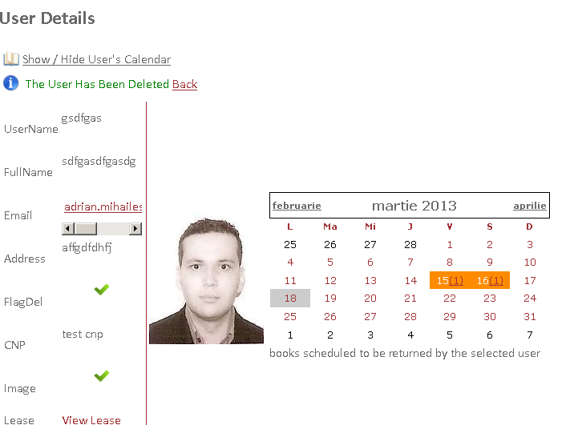

**II.5. Edit User**

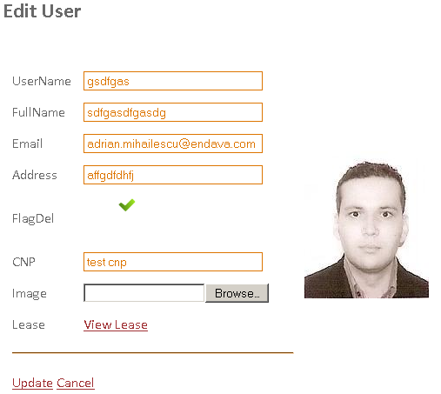

**II.6. View user’s book lease**

In **Users list**, click **View Lease**

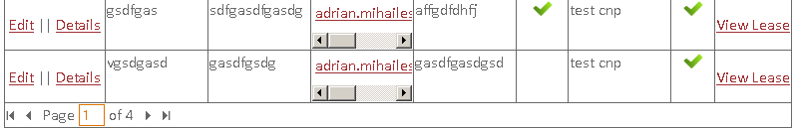

Or

In **Users Details**, click **View Lease**.

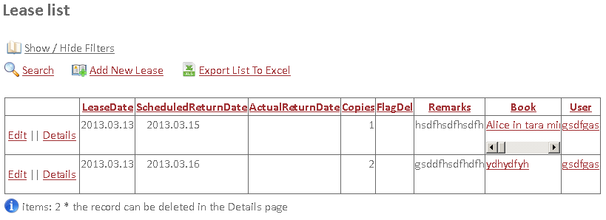

**II.7. Export list to Excel**

The user can export this list to Excel by pressing the button.

1. **Books Lease Page**

This page shows the list with books leases requests made by users

**III.1. Leases list**

The operator cand use filters to search for a specific book lease:

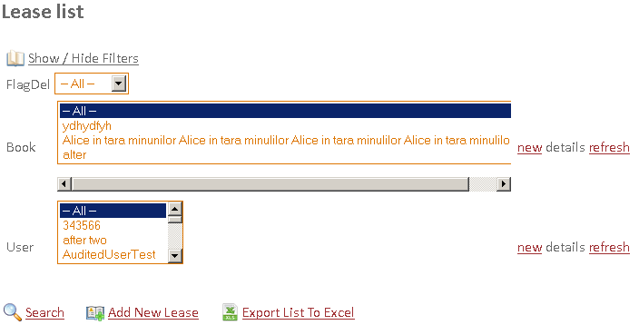

The fields displayed in the report are:

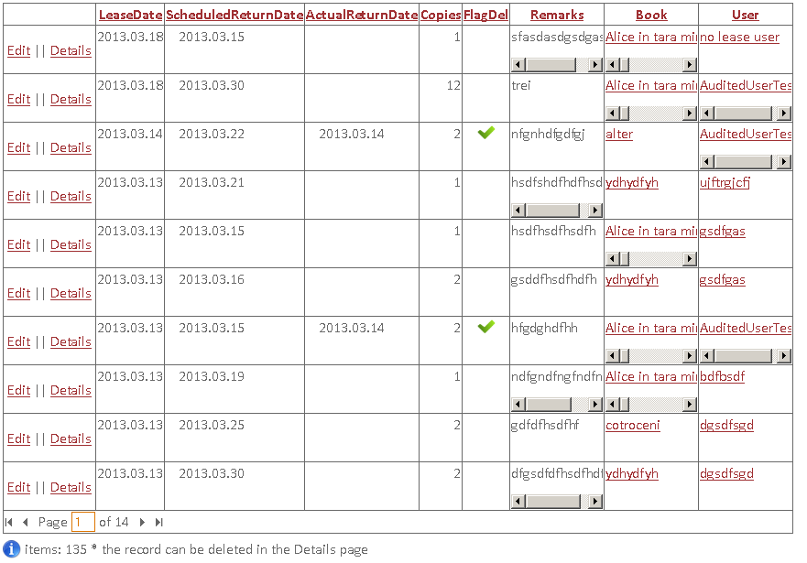

1. **LeaseDate –** the date at which the book lease is made
2. **ScheduledReturnDate** – the date at which the user is scheduled to return the book
3. **ActualReturnDate** – Filled in if the book was returned by the user
4. **Copies** – how many copies did the user lease.
5. **FlagDel** – This field indicates that the lease is no longer active in the system. You can switch to see only the active users by changing the page filters
6. **Remarks** – any other remarks to be stated when the book is leased to the user.
7. **Book** – a link to the book leased by an user
8. **User**  – a link to the user who made the book lease request

This table can be toggled on / off by pressing on the **Show / Hide Filters** link

**III.2. Add New Lease**

**LeaseDate** : will be automatically filled with today’s date

**ScheduledReturnDate**: the scheduled date for the user to return the book

**ActualReturnDate**: will be uneditable. It’s the date at whiich the book was leased to the user.

**Copies**: how many books did the user lease

**Remarks**: any other remark to be stated

**Book**: a list in which you can select the book leases to the user (one selection only)

**User**: a list with the users to whom the book is leased (one selection only)

**new**: click this link to open a page to add a new lease

**refresh**: refreshes the list

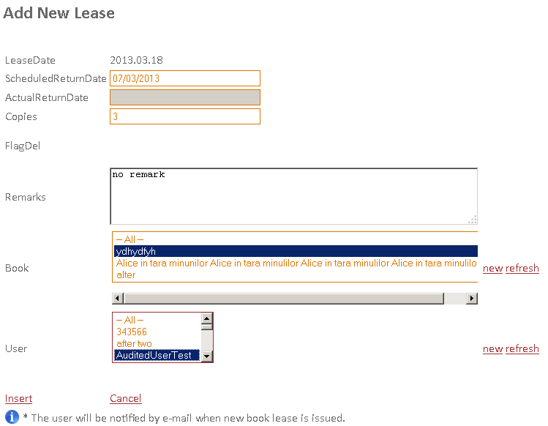

Click **Insert**

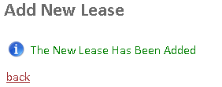

The new user will be added with the no FlagDel.



An e-mail will be sent to the user with the selected book’s details

If the e-mail could not be sent you will be notified with a warning.

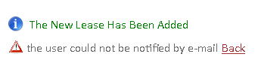

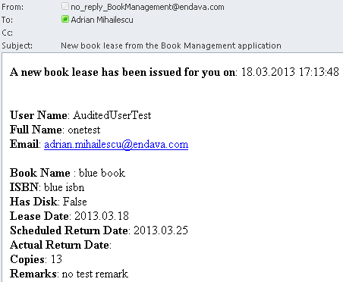

**III.3. Show Lease Details**

Click Details on the book lease’s corresponding row

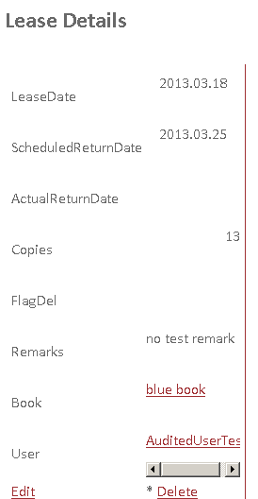

**III.4. Delete Book Lease**

This can be done when the user returns a book

**Confirm** you want to delete this book lease

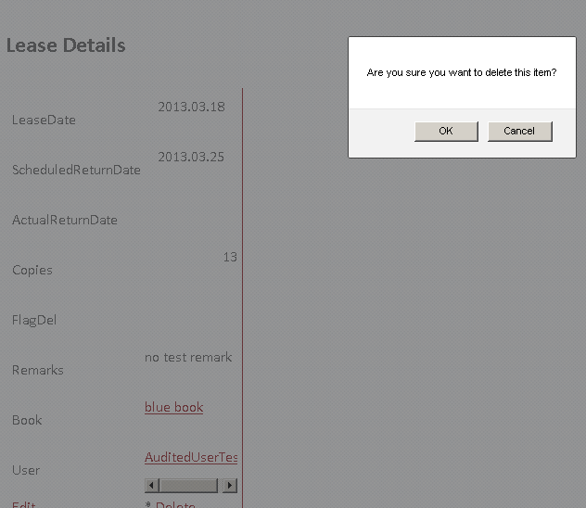

The book lease will be marked as deleted.

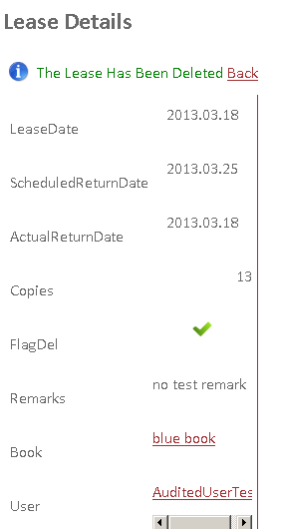

**III.5. Edit Book Lease**

This operation can be done when teh user’s book lease has been inputted with errors.

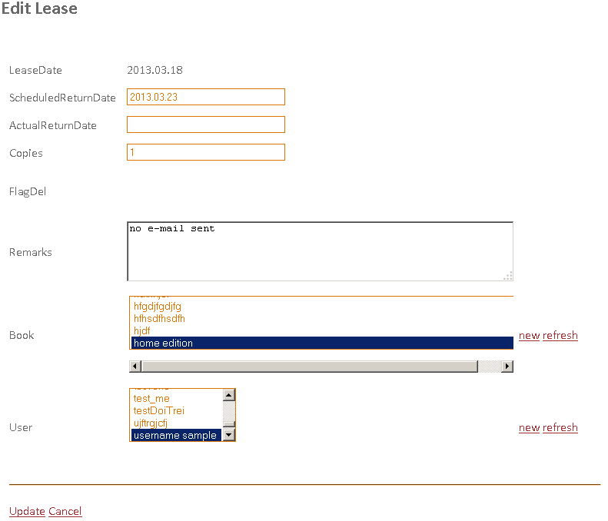

**III.6. View user’s details or book’s details**

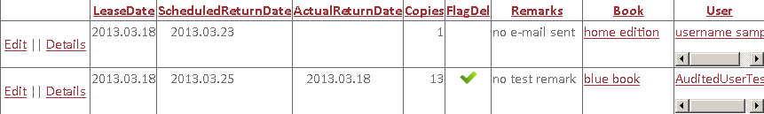

In **Lease List**, click on the link with User or the corresponding link with the Book

Or

In **Lease Details**, click on the link to User or Book.

**III.7. Export list to Excel**

The user can export this list to Excel by pressing the button.

1. **Books Page**

This page displays a list with all books registered in the application’s database

**IV.1. Books list**

The operator cand use filters to search for a specific book:

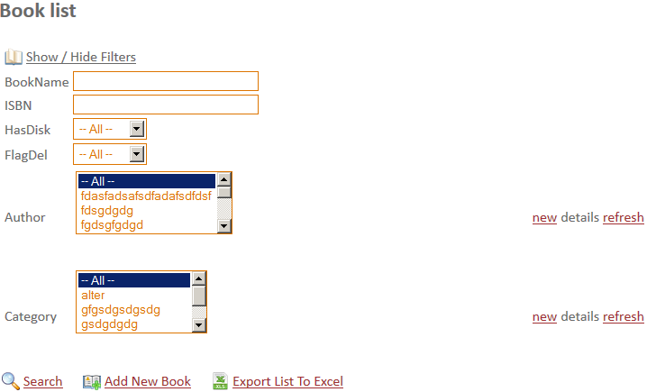

The fields displayed in the report are:

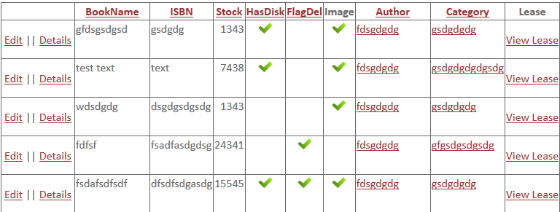

1. **BookName -** the book's name
2. **ISBN** – the book's ISBN (must be unique)
3. **Stock**  – the existing stoc for this book in the library
4. **HasDisk**  – if the book has a disk attached
5. **FlagDel** – This field indicates that the book is no longer active in the system. You can switch to see only the active books by changing the page filters
6. **Author** – a link to the book's author page. Each book must have an author.
7. **Category**  – a link to the book's category page.Each book must be part of a category
8. **Lease** - A link to the book's leases

This table can be toggled on / off by pressing on the **Show / Hide Filters** link

**IV.2. Add New Book**

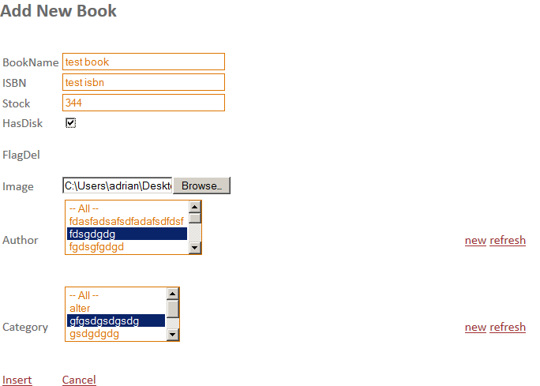

**ISBN**: the unique identifier of the book

**Image**: the book's picture (if available).

The **Image** field is optional (jpg | jped | bmp | png | gif | tif | tiff).

Please enter a valid e-mail address, because this e-mail address will be used to send an e-mail to this user when a new book lease is issued for him / her

Click **Insert**

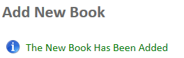

The new user will be added with the no FlagDel.

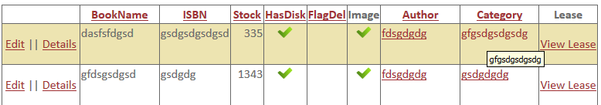

**IV.3. Show Book Details**

Click Details on the book’s corresponding row

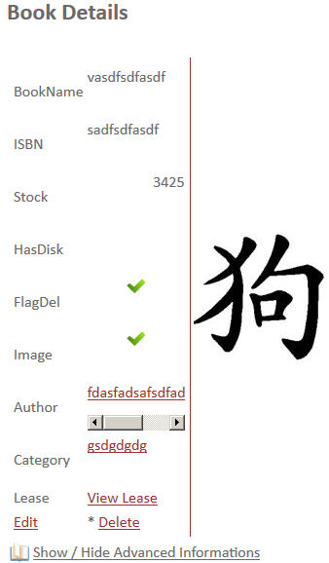

**IV.4. Book’s Advanced Informations**

Shows the book's nearest date of the return and the user who returns the book and how many copies.

This information can be toggled on / off by pressing the **Show / Hide Advanced Informations**

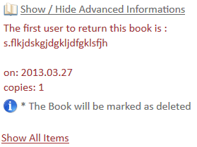

**IV.5. Delete Book**

**Confirm** you want to delete this book

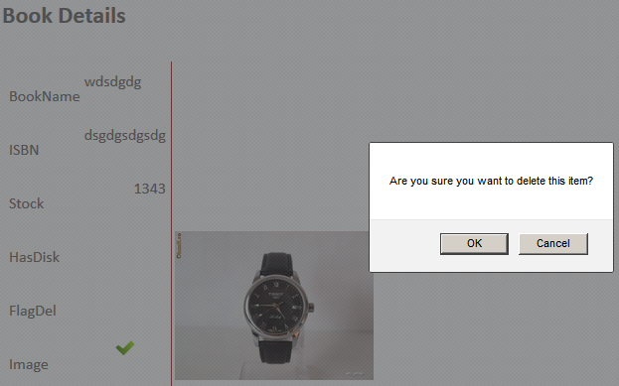

The book will be marked as deleted.

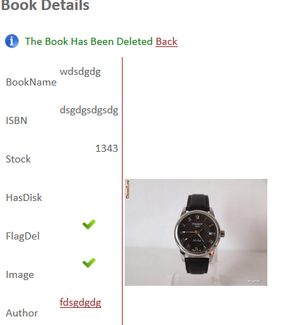

**IV.6. Edit Book**

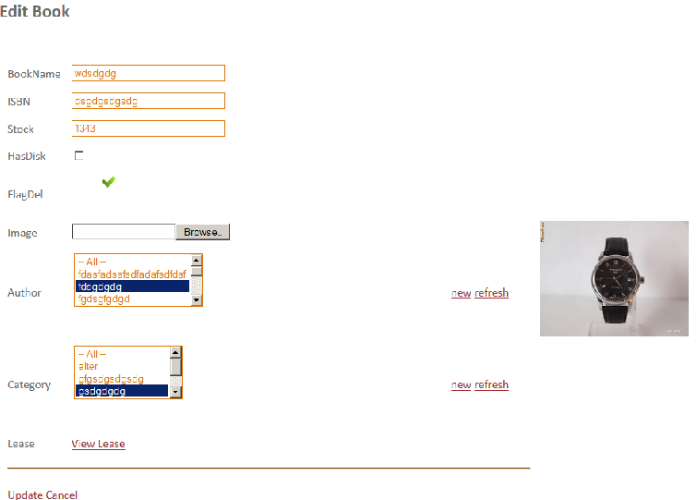

**IV.7. View user’s book lease**

In **Books list**, click **View Lease**



Or

In **Book Details**, click **View Lease**.



**IV.8. Export list to Excel**

The user can export this list to Excel by pressing the button.

**V. Category Page**

This page displays a list with all book categories registered in the application’s database

**V.1. Categories list**

The operator cand use filters to search for a specific book category:

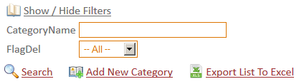

The fields displayed in the report are:

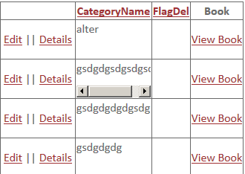

1. **CategoryName = category's name.** Each book must be part of a category
2. **FlagDel** – This field indicates that the user is no longer active in the system. You can switch to see only the active users by changing the page filters
3. **Lease** – shows all the user’s book leases

This table can be toggled on / off by pressing on the **Show / Hide Filters** link

**V.2. Add New Category**

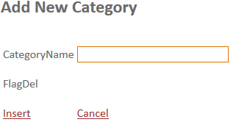

**CagegoryName**: the category's name

Click **Insert**

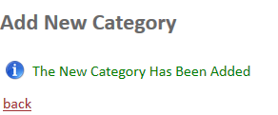

The new category will be added with the no FlagDel.



**V.3. Show Category Details**

Click Details on the category’s corresponding row

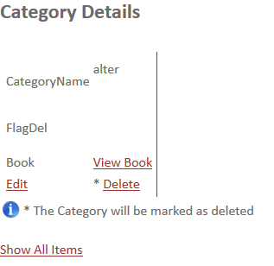

**V.4. Delete Category**

**Confirm** you want to delete this category

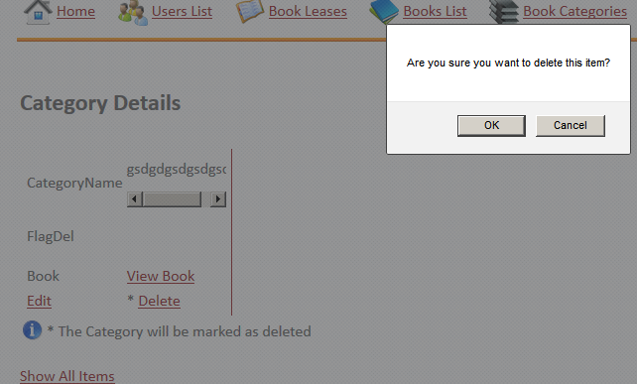

The category will be marked as deleted.

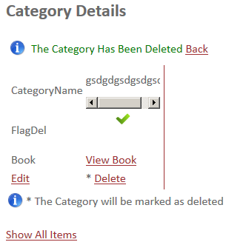

**V.5. Edit Category**

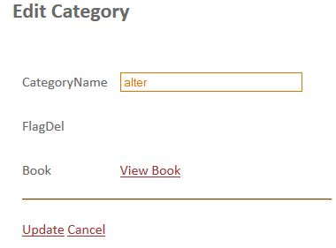

**V.6. View category’s books**

In **Category List**, click **View Category**

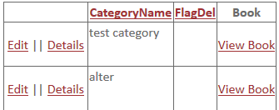

**V.7. Export list to Excel**

The user can export this list to Excel by pressing the button.

**VI. Authors Page**

This page displays a list with all book authors registered in the application’s database

**VI.1. Authors list**

The operator cand use filters to search for a specific book category:

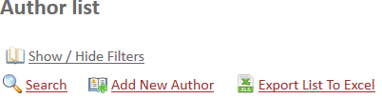

The fields displayed in the report are:

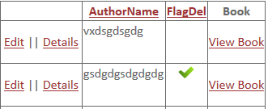

1. **AuthorName = cauthors's name.** Each book must have an author
2. **FlagDel** – This field indicates that the user is no longer active in the system. You can switch to see only the active users by changing the page filters
3. **Book** – shows all the author’s books

This table can be toggled on / off by pressing on the **Show / Hide Filters** link

**VI.2. Add New Author**

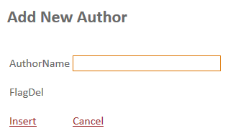

**AuthorName**: the author's name

Click **Insert**

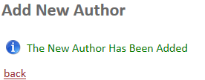

The new author will be added with the no FlagDel.



**VI.3. Show Author Details**

Click Details on the author’s corresponding row

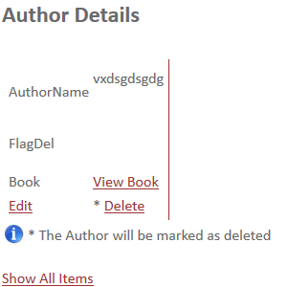

**VI.4. Delete Author**

**Confirm** you want to delete this author

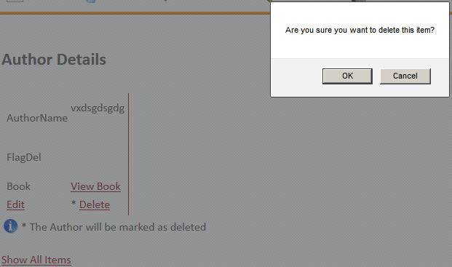

The author will be marked as deleted.

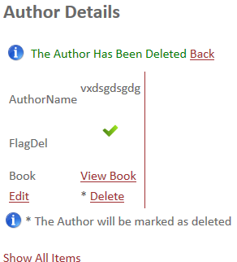

**VI.5. Edit Author**

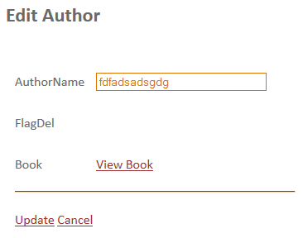

**VI.6. View author’s books**

In **Author List**, click **View Book**

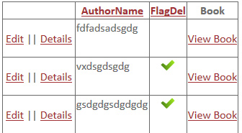

**VI.7. Export list to Excel**

The user can export this list to Excel by pressing the button.